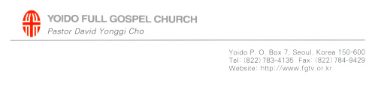
A Life That Lives in Faith

2007. 12. 30. Sunday Sermon at Yoido Full Gospel Church – Seoul, Korea

Speaker: Rev. Yonggi Cho, Senior Pastor
Website: www.fgtv.com

Hebrew 11:1-2 (NIV)
1 Now faith is being sure of what we hope for and certain of what we do not see. 2 This is what the ancients were commended for.

Introduction
We are very often told to live by faith. But when we try to live by faith, we are actually unclear about how to live by faith. .

1. Faith must have hope
Hope refers to a fervent desire (Php 2:13, Ps 37:4).
1) The prayer of Hannah who hoped for a son
ⓛ Hannah’s hope was so fervent that she was struck dumb in her prayer (1Sa 1:10-11).
② The priest Eli thought she was drunk (1Sa 1:13, 17).
2) The widow who cries out to the unjust judge (Lk 18:6-8)

2. Faith is what we hope for
Unclear hope is nothing more than a daydream or fantasy. Clear and detailed hope becomes a dream.
1) Our dream has to be in detail.
ⓛ Picture it.
② Write it down (Php 3:14).
2) We have to look at our dream.
- Abram looked at his dream (Ge 13:14-15, 15:5).

3. Faith itself is not an answer
The substance(KJV: Being sure in NIV) refers to a support.
1) A support on which you put something like a flowerpot
2) Make preparations for God’s answer.
- Open your mouth wide, I will fill it (Eph 3:20).
3) Ask in faith once you have decided to believe (Mk 11:23-24).

4. Faith is being certain of what we do not see
A dream and faith have not yet been fulfilled (Ro 4:17).
1) God calls things that are not as though they were.
2) The confession of our lips is the evidence.
- The confession that calls a dream and faith as though they have been fulfilled (Ro 10:9-10)
3) Abram → Abraham, Sarai → Sarah (Ge 17:5, 15-16)

Conclusion
We need to go through these four steps to have our faith activated. Our faith is activated through our hope, dream, prayer and substance, and the confession of our lips.

