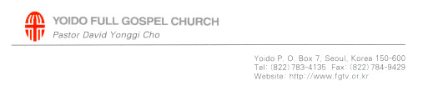

2010 January 03rd

Sunday Sermon at Yoido Full Gospel Church – Seoul, Korea

Speaker: Senior Pastor Emeritus Rev. Yonggi CHO

The Ultimate Concern

1 Co. 2:1-2

Introduction
What is the ultimate concern in our lives? We always have this concern in mind. Jesus told us to seek first God’s kingdom and His righteousness. This means that our ultimate concern should be for the kingdom and righteousness of God.

God’s kingdom and righteousness is to seek the Cross. Through the Cross we dwell in His kingdom and His righteousness. So our ultimate concern should be of Jesus who was crucified. Whether we look up to heaven or down on earth, our hearts should be centered on Jesus Christ.

1. Jesus died on the Cross
- He became a sacrifice for our sins.
- He became a sacrifice for our impurities.
- He became a sacrifice for our sicknesses and diseases.
- He became a sacrifice for our curses.
- He became a sacrifice for our death.
- As we look to the Cross, we should be reminded of our redemption.

2. Returning to the foundation of God’s creation
- Recovery from death of the human spirit since the banishment due to sin.
- The land abundant, now filled with thorns and thistles because of the curse of sin must be recovered by blessings (Gal 3:13; 2Co 8:9)
- The recovered blessings that bring healing and eternal life to those who are diseased and destined for death (3Jn 1:2)

3. Living with the Holy Spirit
- The Spirit has been sent through the grace of the Cross (1Tit 3:5-7)
- The Counselor, The Holy Spirit
- The fruit and the gifts of the Holy Spirit
- Anthropomorphic life

Conclusion
If our lives are centered on the Cross, our every need in life will be satisfied.

